**JIT**

Desc) format: chat – Phone/Vmail(1) – Email …. To the right as seen in image

add link “ALL” in red font….. as seen in image – ALL is default selected

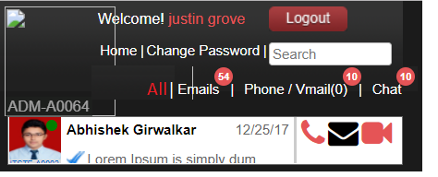

* 1. 4 links – ALL, Email, Phone/Vmail, & chat expanded sections  
     **Comments By Jitendra:-** I will implement this.

1. Select “Chat” link = redirect to: Expanded Chat Dashboard (See IMG)
   * 1. Change title of window to “Chat Dashboard”

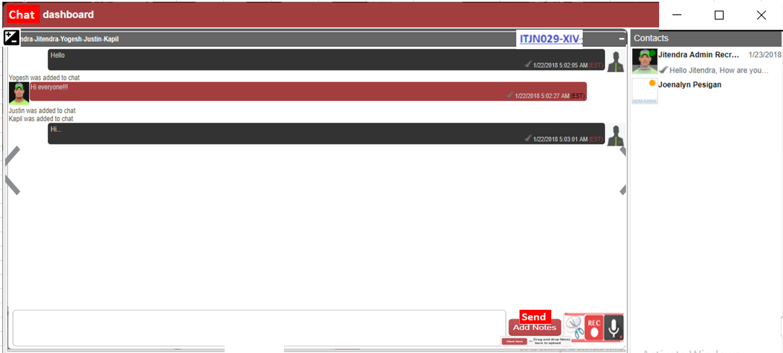  
**Comments By Jitendra:-**

In above image, On right side corner, there is some ID (**ITJN029-XIV**), Please describe it’s functionality.

An enhancement that will come later; ignore for now

On bottom right, there is send button which is fine. Below that I can see **add files** button. So what all file formats (.pdf, .doc, .png etc) would be allowed and what would be the maximum size of each file which is going to be shared. (e.x. 1GB or 10Gb files cannot be shared here etc.)

This is a technical query ask Yogesh- business logic = reuse existing source code(ALWAYS)… snipping tool, screen record and audio are all Kapil past/in progress code….

After that, there is a  icon. If this icon is snipping tool (like snipping tool in window OS), then it cannot be developed in a website. Snipping tool is possible to implement in desktop application only.

Open source API suggestion please

After that, there is a  icon. If this icon is screen recording tool like [**Screen-O-Matic**](https://screencast-o-matic.com/), then it can be easily developed in a desktop application but complex in website. Some open source APIs like **WebRTC** are providing such facility but again this is not fully functional and runs on browser extensions.   
If you have seen it working in any website, please share the URL for our reference.

Open source API suggestion please

After that, there is a  icon which will record audio and send over chat as an attachment. I will implement this.

Open source API suggestion please

1. Select “Phone/Vmail(2)” link = redirect to: Expanded Phone/Vmail(2) Dashboard
   1. Change title of window to “Phone/Vmail(2) Dashboard”  
      **Comments by Jitendra:** Please provide proper wireframe for this “Phone/Vmail Dashboard”. Currently I do not know how exactly it will look like.
   2. ok



1. Select “Email” link = redirect to: Expanded Email Dashboard
   1. Change title of window to “Email Dashboard”  
      **Comments by Jitendra:** Please provide proper wireframe for this “Email Dashboard”. Currently I do not know how exactly it will look like.



1. Select “ALL” link = redirect to: ALL-Telecom Dashboard link
   * 1. Change title of window to “ALL-Telecom Dashboard link”

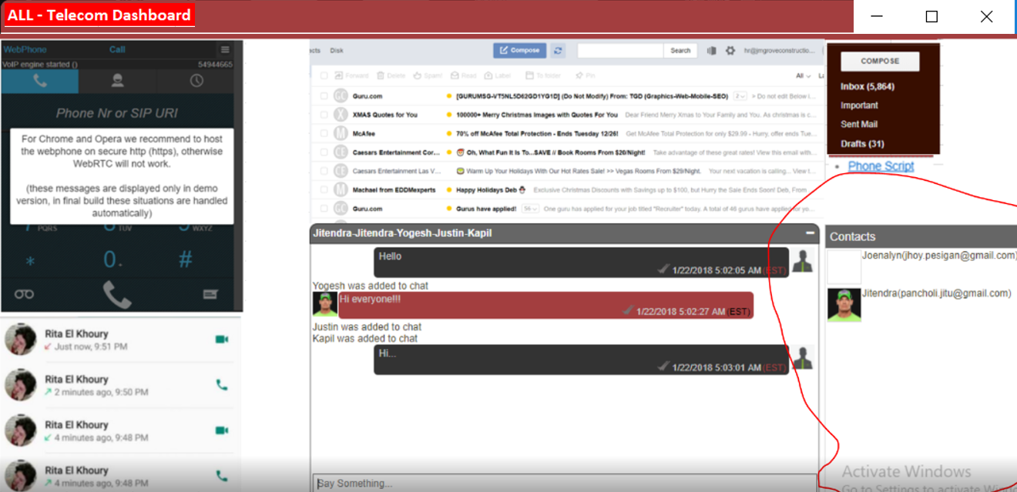

* 1. Add following feature below to all 4 dashboards

  
**Comments by Jitendra:   
First Icon** (minus) will minimize & maximize the whole popup, right?

Yes! Minimized insided the application  
**Second Icon**  will do what? Telecom dashboard popup already opens in full screen view, so please explain the functionality of this icon with proper scenarios.

Telecom opens as Large pop up default – if second icon is selected it will open to full screen! Selected again back to Large

???can the window height and width be expanded/ contracted by select and dragging window edges?  
**Third Icon:** This will close the popup, which is already working.

* 1. Add this IMG  to expanded view of all 4 dashboards; by selecting  it will redirect to “ALL-Telecom Dashboard link”

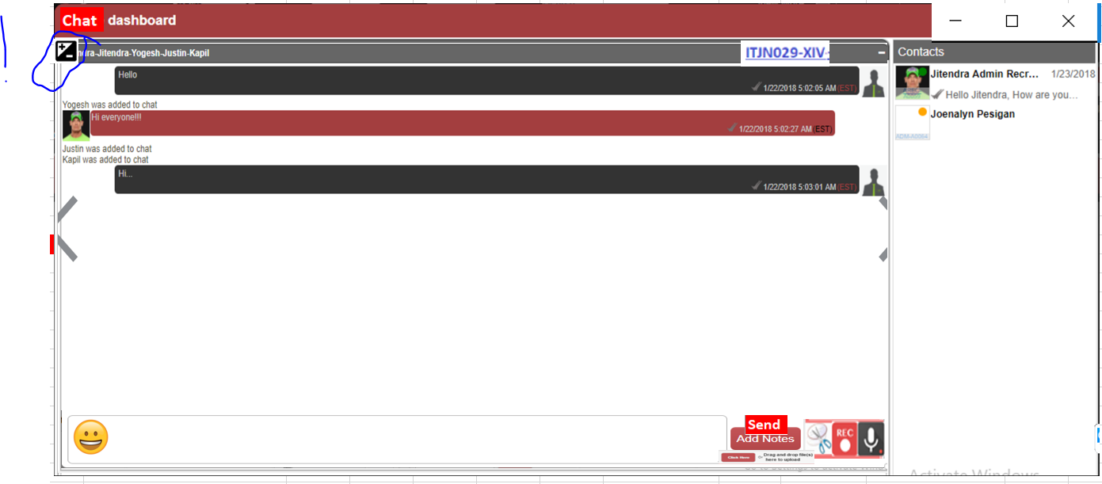

* 1. Add The following notes(SEND) & features to ALL chat windows





Attachments, - reuse existing source UI for how attachment looks in chat LOG  
**Comments by Jitendra:** What all attachments are allowed and their maximum size?

----------------------------------------------------------------------------------------------------------------------------

Discuss later

voicemail, UI for how attachment looks in chat LOG  
**Comments by Jitendra:** Please describe the functionality of voicemail in our application?

screen record !? –   
**Comments by Jitendra:** Already described my concern above for screen recording.

video mail - UI for how attachment looks in chat LOG  
**Comments by Jitendra:** Please describe the functionality of video mail in our application?

share task ID#, **Comments by Jitendra:** Please describe this.

snipping tool, **Comments by Jitendra:** Already shared my concern above.

Emojis: **Comments by Jitendra:** I will implement this.